WEEK 2 TASK
DATA VISUALIZATION AND INSIGHT COMMUNICATION USING R

PROJECT TITLE
SUPERMARKET SALES DATA VISUALIZATION & INSIGHT ANALYSIS USING R

Submitted by: RAJESH M
Tools Used: R Programming / R Studio
Dataset: Supermarket Sales Dataset

TABLE OF CONTENTS
- Introduction
- Dataset Overview
- Objectives of Visualization
- Visualization Design
- Visualization 1 – Sales Distribution
- Visualization 2 – Sales by Product Line
- Visualization 3 – Average Sales by Branch
- Visualization 4 – Average Sales by Customer Type
- Visualization 5 – Quantity vs Sales
- Visualization 6 – Unit Price vs Sales
- Visualization 7 – Daily Sales Trend
- Visualization 8 – Sales by Payment Method
- Key Insights
- Business Recommendations
- Conclusion
- Appendix – R Code

1.INTRODUCTION
Data visualization is an important technique for converting raw data into meaningful and easy-to-understand information. This Week 2 project focuses on analyzing and visualizing supermarket sales data using R programming and RStudio. The analysis uses graphical techniques to identify important trends, patterns, relationships, and variations in the sales data. Multiple visualization methods, including histograms, bar charts, scatter plots, and line charts, were developed to communicate the findings effectively.
The supermarket dataset contains information related to branches, customer types, product lines, gender, quantity, unit price, sales, payment methods, dates, and other transaction-level variables. These variables provide useful information about customer purchasing behavior and sales performance. The visualizations created in this project help compare branches, product categories, customer types, payment methods, and sales-related numerical variables.
The main objective of this analysis is to transform the supermarket transaction data into clear visual insights that can support better business understanding and decision-making. R and the ggplot2 package were used to create the visualizations. Each graph is accompanied by an interpretation explaining the key insight obtained from the data.

2.DATASET OVERVIEW
The dataset used for this project is a supermarket sales transaction dataset containing 1,000 transaction records and 17 variables. The dataset provides detailed information about customer purchases across different supermarket branches. Important variables include Invoice ID, Branch, City, Customer Type, Gender, Product Line, Unit Price, Quantity, Tax, Sales, Date, Time, Payment Method, Cost of Goods Sold, Gross Margin Percentage, Gross Income, and Rating.
The dataset contains three branches: Alex, Cairo, and Giza. It also includes different product lines such as Health and Beauty, Electronic Accessories, Home and Lifestyle, Sports and Travel, Food and Beverages, and Fashion Accessories. Customer transactions are categorized into Member and Normal customer types, while payment methods include Cash, Credit Card, and E-wallet.
For this visualization project, variables such as Sales, Quantity, Unit Price, Branch, Customer Type, Product Line, Date, and Payment Method were selected because they provide useful information for understanding sales performance, customer behavior, product performance, and transaction patterns.

3.OBJECTIVES OF VISUALIZATION
The main objective of this visualization project is to transform supermarket sales data into meaningful visual insights using R programming. The visualizations are designed to make complex transaction information easier to understand and interpret.
The specific objectives of the analysis are:
- To understand the overall distribution of supermarket sales.
- To compare sales performance across different product lines and branches.
- To compare the average sales generated by different customer types.
- To identify the relationship between quantity sold and sales.
- To examine the relationship between unit price and sales.
- To analyze daily changes and trends in sales.
- To compare total sales generated through different payment methods.
- To communicate important business insights through clear and effective charts.
These objectives help convert the raw supermarket transaction data into information that can support business analysis, performance evaluation, and better decision-making.

4.VISUALIZATION DESIGN
The visualization design was developed using R programming and the ggplot2 package to communicate important patterns and relationships in the supermarket sales dataset. Different types of charts were selected according to the nature of the variables and the purpose of each analysis. This approach ensures that the data is presented in a simple, clear, and meaningful form.
A histogram was used to understand the distribution of sales values. Bar charts were used to compare sales across product lines, branches, customer types, and payment methods. Scatter plots were selected to examine relationships between quantity and sales and between unit price and sales. A line chart was used to visualize changes in daily sales over time.
Each visualization was created with appropriate titles, axis labels, and themes to improve readability. The graphs were designed to help a non-technical audience understand the main findings without requiring detailed knowledge of statistical methods. The combination of different visualization techniques provides a comprehensive view of supermarket sales performance and customer transaction patterns.

5.VISUALIZATION 1 – SALES DISTRIBUTION
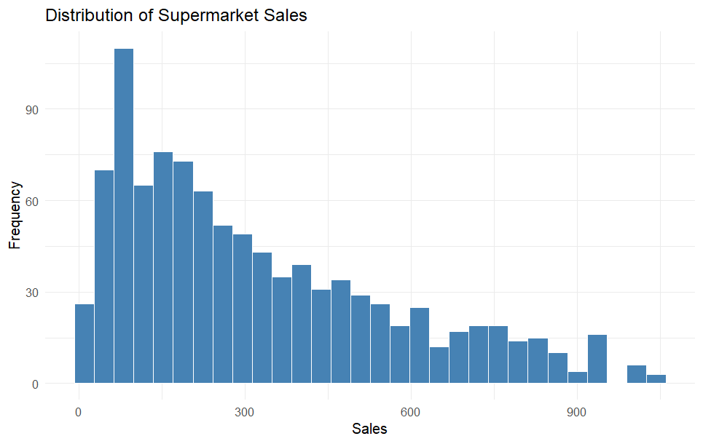

Figure 1: Distribution of Supermarket Sales

The histogram shows that most sales transactions are concentrated in the lower-to-middle sales range, while relatively fewer transactions occur at very high sales values.
This indicates that the sales distribution is positively skewed, with a smaller number of high-value transactions. The visualization provides a clear overview of the overall sales pattern in the dataset.

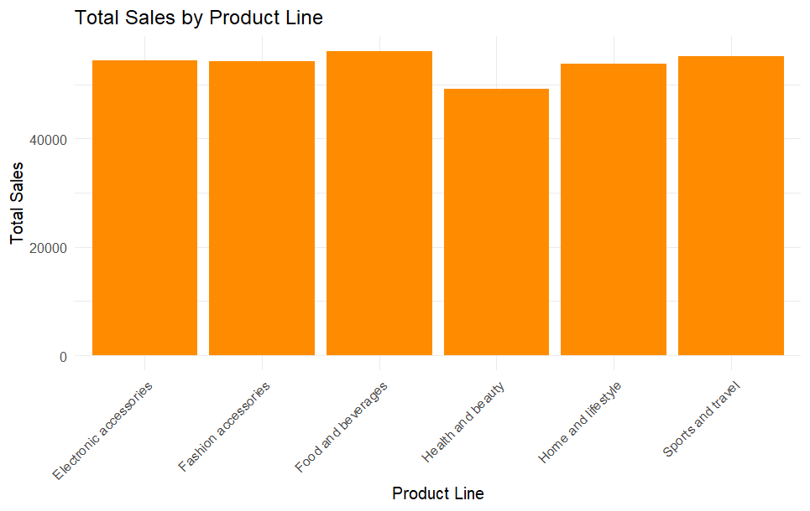
6.VISUALIZATION 2 – SALES BY PRODUCT LINE
Figure 2: Total sales by Product line

This visualization compares the total sales generated by different product lines in the supermarket dataset. A bar chart is used to clearly identify which product categories contribute more to overall sales.
The bar chart shows that sales performance varies across different product lines. Food and beverages, sports and travel, and electronic accessories contribute significantly to total sales, while some other product lines have comparatively lower sales. This comparison helps identify the stronger and weaker product categories and can support decisions related to inventory, marketing, and sales planning.
7. VISUALIZATION 3 – AVERAGE SALES BY BRANCH
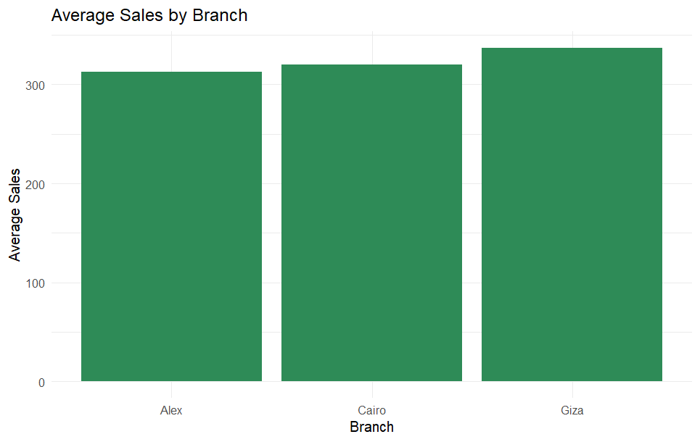
Figure 4: Average Sales by Branch

This visualization compares the average sales performance across the three supermarket branches. A bar chart is used to identify differences in the average sales generated by each branch.
The chart shows that the branches have relatively similar average sales, with Giza showing slightly higher average sales compared with Alex and Cayo. This comparison helps understand branch-level performance and can support decisions related to resource allocation and sales improvement.

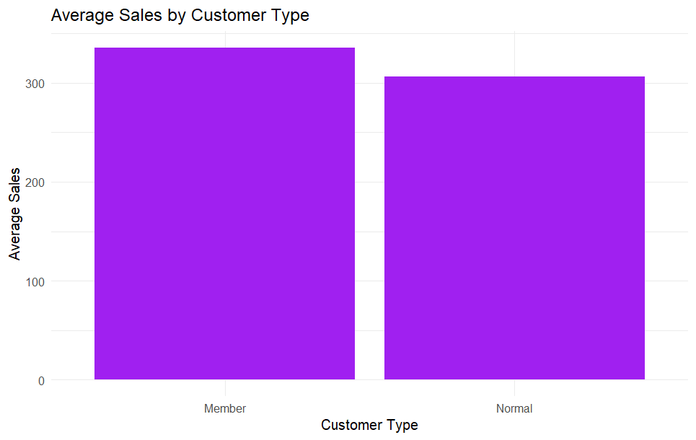
8.VISUALIZATION 4 – AVERAGE SALES BY CUSTOMER TYPE
Figure 5: Average Sales by Customer Type

This visualization compares the average sales generated by different customer types. A bar chart is used to identify differences in purchasing performance between Member and Normal customers.
The chart shows that Member customers have a slightly higher average sales value compared with Normal customers. This indicates that membership customers contribute positively to sales performance. The finding can help the supermarket understand customer behavior and develop suitable membership benefits and promotional strategies.

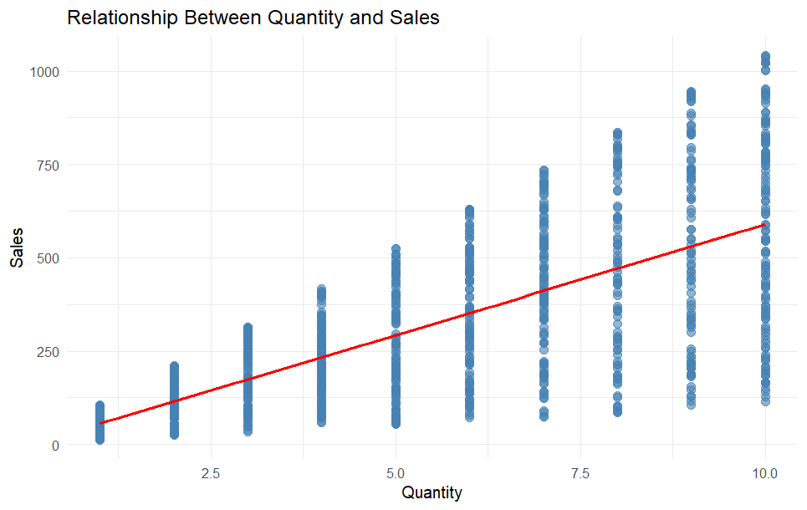
9.VISUALIZATION 5 – QUANTITY VS SALES
Figure 6: Relationship Between Quantity and Sales

This visualization examines the relationship between the quantity of products sold and the total sales value. A scatter plot with a trend line is used to understand whether sales increase as the quantity sold increases.
The graph shows a positive relationship between quantity and sales. As the quantity sold increases, the sales value generally tends to increase. This indicates that higher quantities of products sold contribute to higher sales revenue.

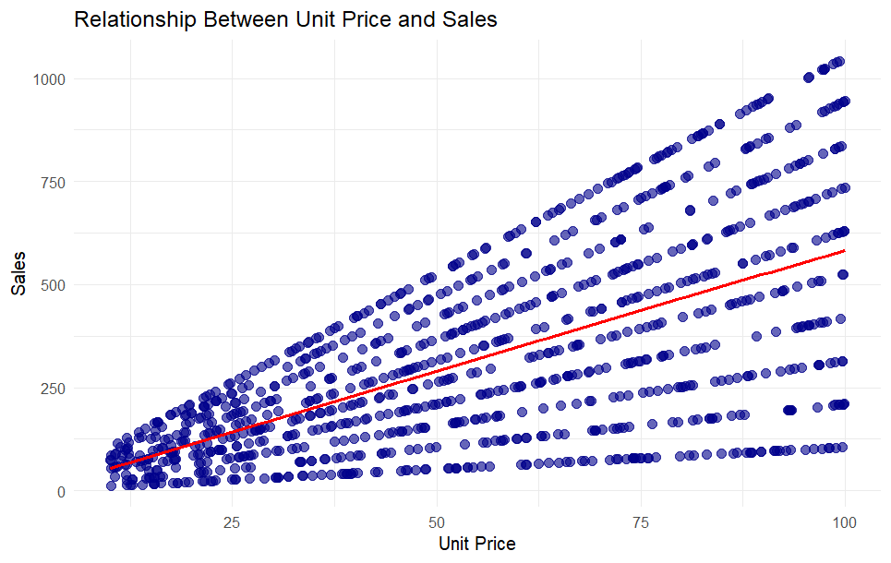
10.VISUALIZATION 6 – UNIT PRICE VS SALES
Figure 7: Relationship Between Unit Price and Sales

This visualization examines the relationship between the unit price of products and total sales. A scatter plot with a trend line is used to identify whether changes in unit price are associated with changes in sales.
The graph shows a positive relationship between unit price and sales. As the unit price increases, the sales value generally tends to increase. This indicates that higher-priced transactions can contribute to higher sales revenue

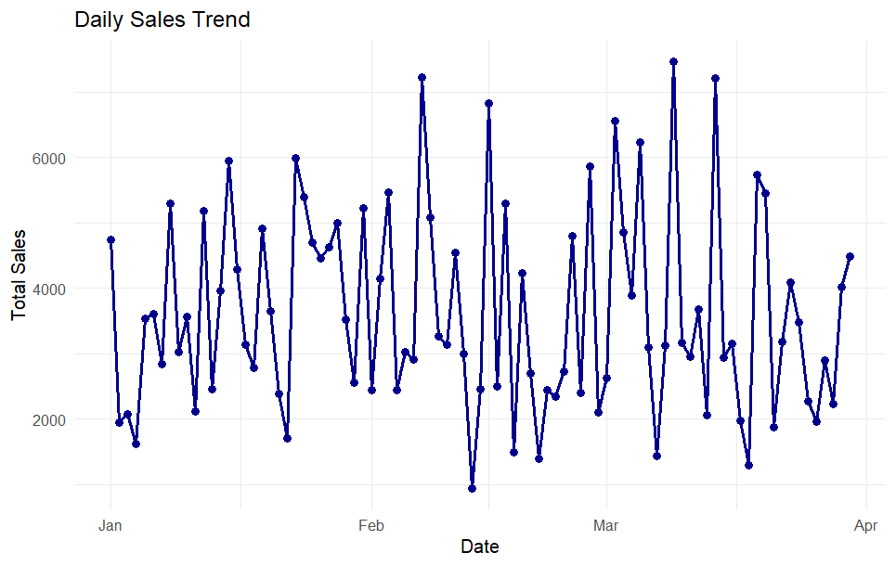
11. VISUALIZATION 7 – DAILY SALES TREND
Figure 8: Daily Sales Trend

This visualization shows the changes in total sales over time. A line chart is used to identify daily fluctuations and overall patterns in supermarket sales.
The graph shows considerable variation in daily sales, with several peaks and low-sales periods throughout the observation period. Sales do not follow a consistent upward or downward trend. This visualization helps identify fluctuations in daily performance and can support sales planning and resource management.

12. VISUALIZATION 8 – SALES BY PAYMENT METHOD
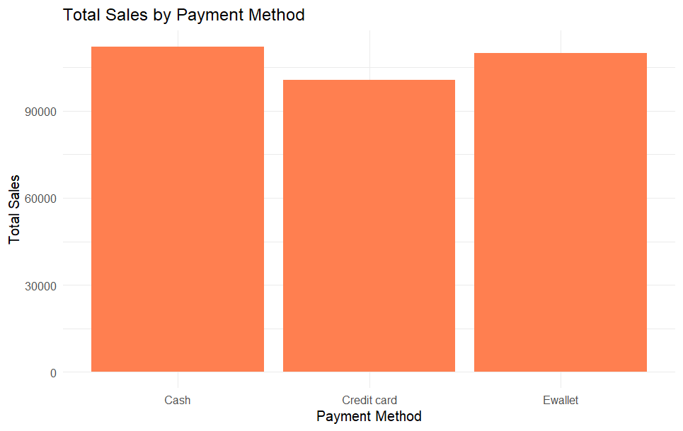

Figure 9: Total Sales by Payment Method
This visualization compares the total sales generated through different payment methods. A bar chart is used to understand customer payment preferences and compare the contribution of each payment method to total sales.
The chart shows that Cash contributes the highest total sales among the payment methods, followed by E-wallet and Credit Card. The results indicate that customers use multiple payment options, with cash remaining an important payment method in the analyzed dataset. This information can help the supermarket maintain suitable payment facilities and improve the customer checkout experience.
13. KEY INSIGHTS
The visualization analysis provided several important insights into supermarket sales performance and customer purchasing behavior. The graphical analysis made it easier to identify patterns, differences, and relationships within the transaction data.
- Sales Distribution: Most transactions are concentrated within the lower-to-middle sales range, while very high-value transactions occur less frequently.
- Product Line Performance: Sales performance varies across product categories. Food and Beverages shows strong overall sales performance.
- Branch Performance: Giza records the highest average sales among the three branches, indicating relatively strong branch-level performance.
- Customer Type: Member customers show a slightly higher average sales value than Normal customers, highlighting the potential value of customer loyalty programs.
- Quantity and Sales: The scatter plot shows a positive relationship between quantity sold and sales. Higher quantities generally result in higher sales values.
- Unit Price and Sales: Unit Price and Sales also show a positive relationship in the analyzed dataset.
- Daily Sales: Daily sales fluctuate considerably, with several high and low sales periods.
- Payment Method: Cash contributes the highest total sales among the payment methods, while E-wallet and Credit Card also contribute significantly.

14. BUSINESS RECOMMENDATIONS
Based on the visualization results, several business recommendations can be suggested to improve supermarket sales performance and customer engagement.
- Strengthen high-performing product lines: Maintain sufficient inventory for products and categories that generate higher sales and ensure their availability.
- Improve lower-performing categories: Analyze customer preferences and introduce suitable promotions for product lines with comparatively lower sales.
- Focus on branch performance: Study the successful practices of high-performing branches and apply suitable strategies to branches with lower performance.
- Strengthen loyalty programs: Since Member customers show higher average sales, the supermarket can provide reward points, member-exclusive offers, and personalized promotions.
- Encourage higher-value purchases: Product bundles and cross-selling strategies can be used to increase transaction value.
- Monitor daily sales fluctuations: Daily sales trends should be regularly monitored to improve inventory planning and promotional scheduling.
- Maintain multiple payment options: Cash, E-wallet, and Credit Card facilities should all be maintained to provide customers with convenient payment choices.
- Use data-driven decision-making: Regular visualization and analysis of sales data can help management monitor performance and make better business decisions.
15. CONCLUSION
The Week 2 project successfully demonstrated how R programming can be used to visualize and communicate insights from supermarket sales data. Different visualization techniques, including histograms, bar charts, scatter plots, and line charts, were used to analyze sales performance, product categories, branches, customer types, payment methods, and relationships between numerical variables.
The analysis showed that sales performance varies across product lines and branches, with Giza recording the highest average branch sales. Member customers showed slightly higher average sales than Normal customers. The scatter plots indicated positive relationships between quantity and sales and between unit price and sales. The daily sales trend also showed considerable fluctuations across the analyzed period.
Overall, the project demonstrates that effective data visualization can transform complex transaction data into clear and meaningful business insights. These insights can support better decisions related to inventory management, customer retention, marketing strategies, sales planning, and payment facilities. The project also provided practical experience in using R and ggplot2 for real-world data visualization and analytical communication.

16.APPENDIX – R CODE
library(ggplot2)

supermarket <- read.csv(file.choose())
head(supermarket)
str(supermarket)
# 1. Sales Distribution
ggplot(supermarket, aes(x = Sales)) +
geom_histogram(
bins = 30,
fill = "steelblue",
color = "white"
) +
labs(
title = "Distribution of Supermarket Sales",
x = "Sales",
y = "Frequency"
) +
theme_minimal()

# 2. Total Sales by Product Line
product_sales <- aggregate(
Sales ~ Product.line,
data = supermarket,
FUN = sum
)

ggplot(product_sales, aes(x = Product.line, y = Sales)) +
geom_bar(stat = "identity", fill = "darkorange") +
labs(
title = "Total Sales by Product Line",
x = "Product Line",
y = "Total Sales"
) +
theme_minimal()

# 3. Average Sales by Branch
branch_sales <- aggregate(
Sales ~ Branch,
data = supermarket,
FUN = mean
)

ggplot(branch_sales, aes(x = Branch, y = Sales)) +
geom_bar(stat = "identity", fill = "seagreen") +
labs(
title = "Average Sales by Branch",
x = "Branch",
y = "Average Sales"
) +
theme_minimal()

# 4. Average Sales by Customer Type
customer_sales <- aggregate(
Sales ~ Customer.type,
data = supermarket,
FUN = mean
)

ggplot(customer_sales, aes(x = Customer.type, y = Sales)) +
geom_bar(stat = "identity", fill = "purple") +
labs(
title = "Average Sales by Customer Type",
x = "Customer Type",
y = "Average Sales"
) +
theme_minimal()

# 5. Relationship Between Quantity and Sales
ggplot(supermarket, aes(x = Quantity, y = Sales)) +
geom_point(
color = "steelblue",
alpha = 0.6,
size = 2.5
) +
geom_smooth(
method = "lm",
se = FALSE,
color = "red"
) +
labs(
title = "Relationship Between Quantity and Sales",
x = "Quantity",
y = "Sales"
) +
theme_minimal()

# 6. Relationship Between Unit Price and Sales
ggplot(supermarket, aes(x = Unit.price, y = Sales)) +
geom_point(
color = "darkblue",
alpha = 0.6,
size = 2.5
) +
geom_smooth(
method = "lm",
se = FALSE,
color = "red"
) +
labs(
title = "Relationship Between Unit Price and Sales",
x = "Unit Price",
y = "Sales"
) +
theme_minimal()

# 7. Daily Sales Trend
supermarket$Date <- as.Date(
supermarket$Date,
format = "%m/%d/%Y"
)

daily_sales <- aggregate(
Sales ~ Date,
data = supermarket,
FUN = sum
)

ggplot(daily_sales, aes(x = Date, y = Sales)) +
geom_line(color = "darkblue", linewidth = 1) +
geom_point(color = "darkblue", size = 2) +
labs(
title = "Daily Sales Trend",
x = "Date",
y = "Total Sales"
) +
theme_minimal()

# 8. Total Sales by Payment Method
payment_sales <- aggregate(
Sales ~ Payment,
data = supermarket,
FUN = sum
)

ggplot(payment_sales, aes(x = Payment, y = Sales)) +
geom_bar(stat = "identity", fill = "coral") +
labs(
title = "Total Sales by Payment Method",
x = "Payment Method",
y = "Total Sales"
) +
theme_minimal()

17. REFERENCES
  - Wickham, H., & Grolemund, G. (2017). R for Data Science: Import, Tidy, Transform, Visualize, and Model Data. O'Reilly Media.
  - RStudio. (2025). RStudio IDE Documentation. Posit Software, PB
  - Supermarket Sales Dataset. Dataset used for the analysis and visualization project

